Applying the Machine Learning in Forced Convection:
What you already have:
- Dimensions of the rod (diameter and length)
- Properties of the copper rod
- Pitot-static pressure (mm of water) [This will help you to calculate the velocity]
- Time-based reading of rod temperature and the ambient temperature
What you will be provided with:
A computer with Tensorflow code using python libraries via Github and Importantly the dataset from the experiment in CSV file format
What you will execute:
- Run the code
- Plot the following charts:
- MSE vs Epoch
- MAE vs Epoch
- Predictions vs test values
- Error Distribution for h
Steps:

- Understand your data, what are the inputs and what are the outputs. Avoid fixed parameters like thermal conductivities, thermal resistances and plate thicknesses.
  - Inputs: temperature measurements T₀, T_{rod}, velocity [readings taken at t = 90 sec]
  - Outputs: heat transfer coefficient h
- Upload the data:
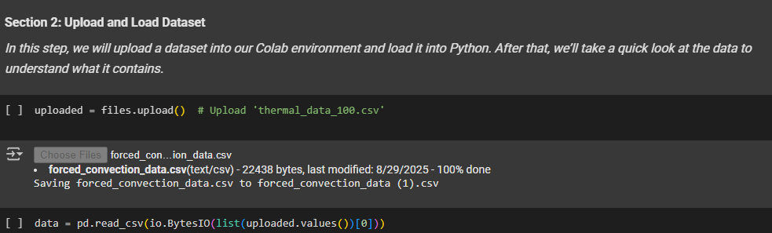

- Differentiate the inputs and outputs from the uploaded CSV file:
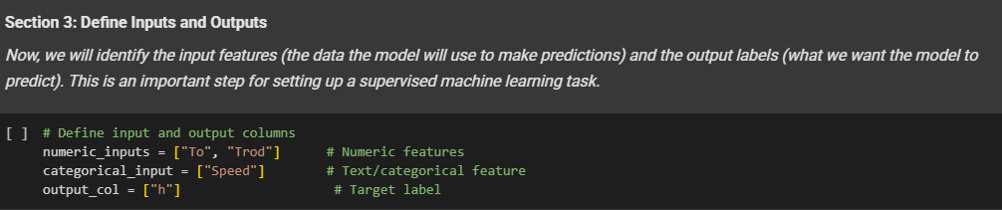

- Split your data into training and testing sets:
    - Use 80% for training the ML model.
    - Use 20% for testing/validation.
(You may also try 85-15%, etc., and compare results.)
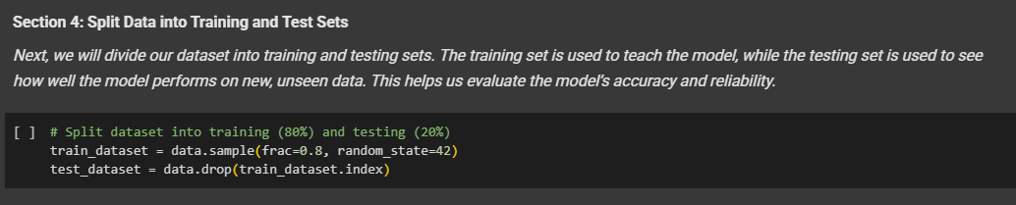
- Prepare your data for Machine Learning:
Normalize your data (scale input features so they have similar ranges, e.g., between 0 and 1).
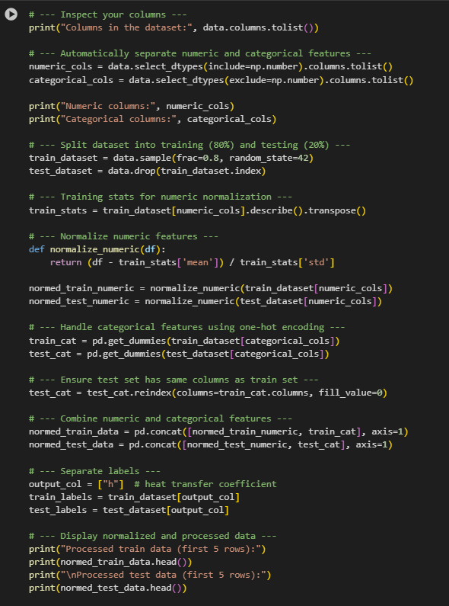
- Build a Simple Neural Network Model in TensorFlow
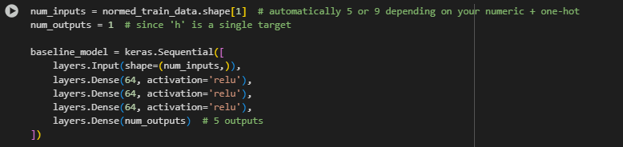
You can see in the above screenshot that we have three hidden layers with each layer having 64 neurons with ‘relu’ as the activation function. You may change the architecture based on your choices.
(vii) Compile the model
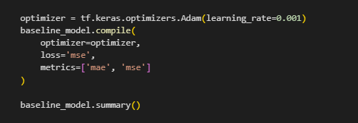

- Train the model
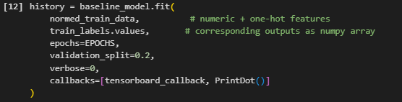

- Plot the MSE and MAE metrics with respect to epochs:
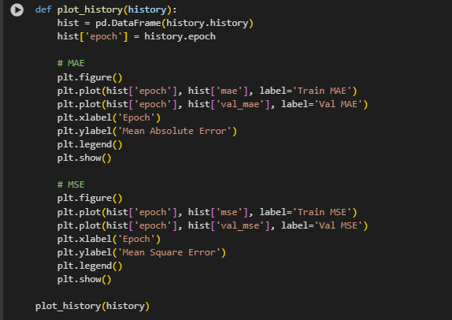
- Plot remaining graphs of predictions vs test values and error distribution.

Lab Report Questions:

1. Compare your ML model's h with the h calculated using slope. Which performs better and why?

2. What features seem most important for predicting heat transfer coefficient?

3. How would you improve the model with more data?

4. Discuss the trade-offs between ML models and traditional correlations.

